7.3 GitHub Repository Documentation
Auto Ticket Classification Using Flow Designer
- Brainstorming & Ideation
- Requirement Analysis
- Project Design Phase
- Project Planning Phase
- Project Development Phase
- Project Testing
- Project Documentation
- Project Demonstration

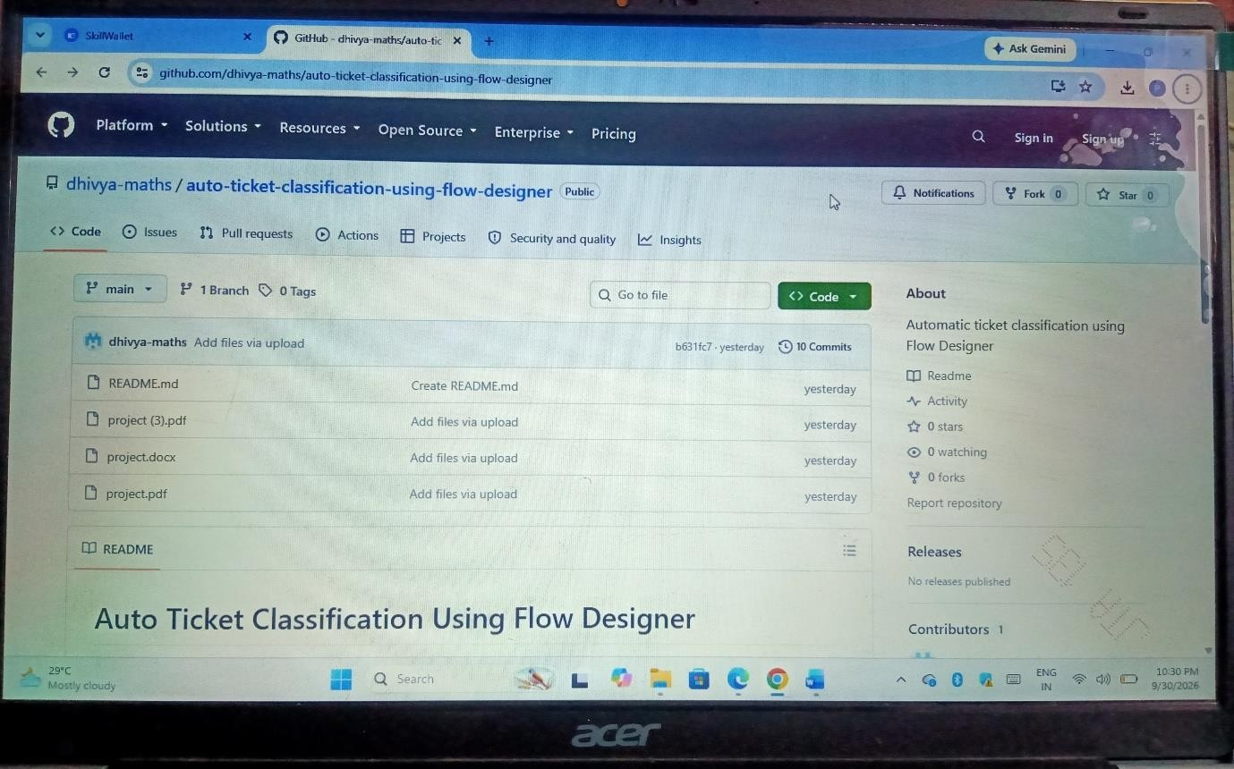

GitHub Repository Structure

